https://surajuttam.wordpress.com/2016/03/28/scratch-syntonicity-and-the-programming-puzzle/

Scratch, Syntonicity, and the Programming Puzzle

Suraj Uttam, 28th March 2016
Let us consider briefly programming for children! Programming? For children!? BUT HOW!? I know that is what your internal monologue is currently saying.
Consider Scratch, the youth community around programming located at scratch.mit.edu. Scratch allows users to work with sprites of their choosing and uses puzzle pieces as the coding language. Check out this picture of a project I worked on this week:
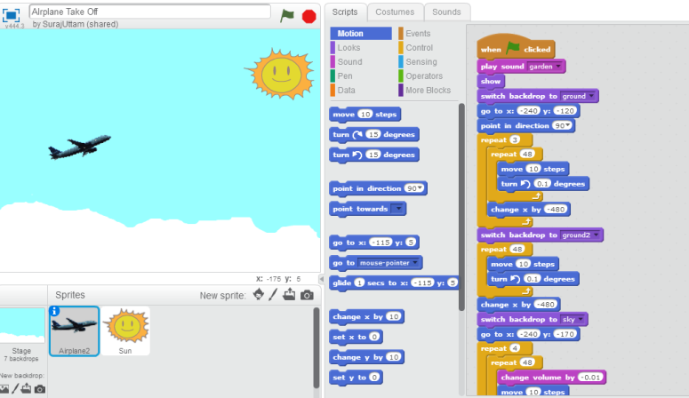
Consistent with the motif of airplanes that has threaded through these blog posts, I drew an airplane taking off. I say “drew” rather than programmed because when all is said in done what I have done feels like more art than science…
A productive experience, indeed. ... Sometimes I tried numbers until they ‘felt’ right and only later understood what I was doing in a mathematical sense (see for example the angle of change).
I was not terribly surprised that I enjoyed my Scratch experience. I had a pretty clear goal once I had thought about it (make it look like the plane was taking off) and quickly I realized that adding more things (e.g., changing backgrounds) would perfect the idea. I also identify with programming/math in as far as I don’t find the process too intimidating.
What did surprise me was how much Scratch felt like art rather than programming. At the moment I attribute this to the fact that I was essentially animating. This may not be the nature of all Scratch projects but it did feel like a natural enough thing to do given the interface. Animating is, of course, artistic in nature.
According to Google dictionary, syntonic means:
(of a person) responsive to and in harmony with their environment so that affect is appropriate to the given situation
In talking through the “turtle geometry” of the language Logo, in which a turtle can be programmed to walk around a screen, Papert highlights the activity as body syntonic, ego syntonic, and culturally syntonic. By this he means that the body, ego, and cultural (social) realities of the learner are meaningfully brought to bear in the activity; there is a reciprocity between the learner’s existing experiences and emotions and the task at hand.
Does Scratch share these same syntonicities? It is certainly culturally syntonic in that the characters, backgrounds, and activities at hand are made personally meaningful. The learner can choose sprites and so on that they actually want to use. It inherits Logo’s ego syntonicity in that “it is coherent with children’s sense of themselves as people with intentions, goals, desires, likes, and dislikes” (Mindstorms, Papert, p. 63).
But what of body syntonicity, which Papert calls “firmly related to children’s sense and knowledge about their own bodies” (p. 63). I see this present in Logo, where kids “play turtle,” pretending to be the turtle on the screen, in order to make sense of how to program it to walk particular ways. For some Scratch activities, this is surely still an applicable strategy. But Scratch isn’t body syntonic for all activities therein. This lack of body syntonicity poses a tiny dilemma. As I see it, there are a few ways out of this dilemma-ette:
- Something must be noted about this: Logo is/was only body syntonic if made so. Calling attention to instruction, nothing about Logo automatically suggested that learners should play turtle. It was only through a teacher’s direction that the connection was made. Because Scratch may be used by kids at home without much guidance, it may not be the case that body syntonicity is altogether that likely. But neither was it so in Logo.
- Another way out: body syntonicity is not that important. Papert wasn’t suggesting that all things should be body syntonic – just that they should be somehow syntonic. In this way, what Scratch loses in body syntonicity it more than makes up for in increased ego/cultural syntonicity.
- A third way out: for younger kids body syntonicity is vital since the bodies make the most sense. But as learners grow older they have more experiences and resources available to them (to which to relate). Since Scratch is aimed at slightly older children, the importance of body syntonicity is diminished.

